|  |  |
| --- | --- |
| **1.Javascript - Way of Adding JavaScript** | **Date: 13-16-2023** |

**Topics**

## What

## **What is JavaScript?**

Jjj

Note- Priorities learn yourself.

## **Script Tag in JavaScript**

## **How to link more than one External JavaScript**

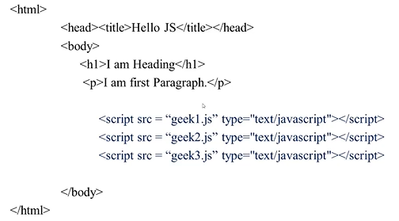

**How to use Inline and External together in JavaScript**

**Not a correct way**

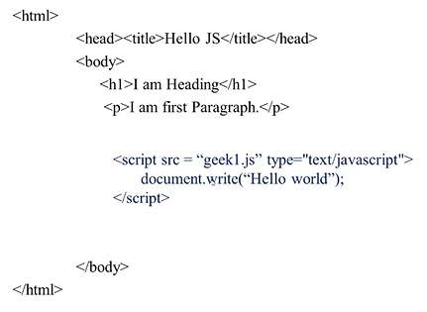

**Correct Way**

